

Foundations of Programming

Assignment No.: 22
PROBLEM STATEMENT: Write a menu driven program in C to perform various string operations using in-built functions.

OBJECTIVE:

- To understand the concept of strings in the C programming language.
- To learn how to use built-in string functions for string manipulation.
- To perform operations such as length calculation, copying, concatenation, comparison, and reversal using menu options.
.

THEORY:
In the C programming language, a string is a sequence of characters terminated by a null character ('\0'). Strings are stored in character arrays and manipulated using functions available in the string.h header file.
Common built-in string functions include strlen() for finding the length of a string, strcpy() for copying one string to another, strcat() for concatenating two strings, and strcmp() for comparing two strings.
A menu driven program allows the user to select different operations from a list of options. Based on the user’s choice, the corresponding string function is executed. This approach makes the program interactive and easy to use.

PLATFORM: Linux
ALGORITHM::

- Start
- Declare character arrays str1, str2, temp and integer variable choice.
- Display the menu with options:
  - Length
  - Copy
  - Concatenate
  - Compare
  - Reverse
  - Substring
  - Exit
- Read the user’s choice.
- Repeat steps until user selects Exit (0):
Case 1: Length of String
  - Read a string into str1.
  - Remove newline character.
  - Find length using strlen(str1).
  - Display the length.
Case 2: Copy String
  - Read a string into str1.
  - Remove newline character.
  - Copy str1 into temp using strcpy(temp, str1).
  - Display the copied string.
Case 3: Concatenate Strings
  - Read first string into str1.
  - Read second string into str2.
  - Remove newline characters.
  - Join strings using strcat(str1, str2).
  - Display the concatenated string.
Case 4: Compare Strings
  - Read two strings into str1 and str2.
  - Remove newline characters.
  - Compare using strcmp(str1, str2).
  - If result is 0, strings are equal; otherwise not equal.
  - Display the result.
Case 5: Reverse String
  - Read a string into str1.
  - Remove newline character.
  - Reverse the string manually by swapping characters from both ends.
  - Display the reversed string.
Case 6: Check Substring
  - Read main string into str1.
  - Read substring into str2.
  - Remove newline characters.
  - Use strstr(str1, str2) to check for substring.
  - If not NULL, substring is found; otherwise not found.
  - Display the result.
Case 0: Exit
  - Display exit message.
  - Terminate the loop.
- Stop

FLOWCHART:
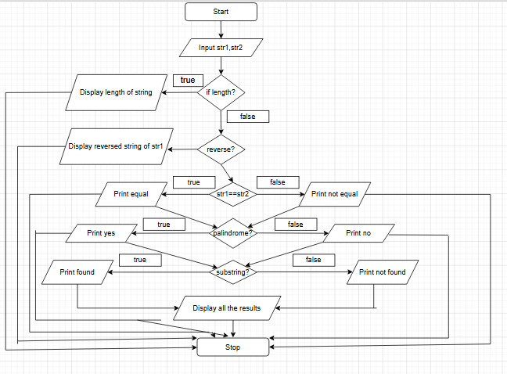
CODE:
#include <stdio.h>
#include <string.h>

// Helper to remove newline from fgets
void removeNewline(char s[]) {
s[strcspn(s, "\n")] = '\0';
}

// Manual reverse (no standard built-in)
void reverseString(char s[]) {
int i, len = strlen(s);
for (i = 0; i < len / 2; i++) {
char temp = s[i];
s[i] = s[len - i - 1];
s[len - i - 1] = temp;
}
}

int main() {
char str1[100], str2[100], temp[100];
int choice;

do {
printf("\n--- STRING OPERATIONS MENU ---\n");
printf("1. Length of string\n");
printf("2. Copy string\n");
printf("3. Concatenate strings\n");
printf("4. Compare strings\n");
printf("5. Reverse string\n");
printf("6. Check substring\n");
printf("0. Exit\n");
printf("Enter your choice: ");
scanf("%d", &choice);
getchar(); // clear newline

switch (choice) {
case 1:
printf("Enter a string: ");
fgets(str1, sizeof(str1), stdin);
removeNewline(str1);
printf("Length = %lu\n", strlen(str1));
break;

case 2:
printf("Enter a string: ");
fgets(str1, sizeof(str1), stdin);
removeNewline(str1);
strcpy(temp, str1);
printf("Copied string: %s\n", temp);
break;

case 3:
printf("Enter first string: ");
fgets(str1, sizeof(str1), stdin);
removeNewline(str1);
printf("Enter second string: ");
fgets(str2, sizeof(str2), stdin);
removeNewline(str2);
strcat(str1, str2);
printf("Concatenated string: %s\n", str1);
break;

case 4:
printf("Enter first string: ");
fgets(str1, sizeof(str1), stdin);
removeNewline(str1);
printf("Enter second string: ");
fgets(str2, sizeof(str2), stdin);
removeNewline(str2);
if (strcmp(str1, str2) == 0)
printf("Strings are equal\n");
else
printf("Strings are not equal\n");
break;

case 5:
printf("Enter a string: ");
fgets(str1, sizeof(str1), stdin);
removeNewline(str1);
reverseString(str1);
printf("Reversed string: %s\n", str1);
break;

case 6:
printf("Enter main string: ");
fgets(str1, sizeof(str1), stdin);
removeNewline(str1);
printf("Enter substring: ");
fgets(str2, sizeof(str2), stdin);
removeNewline(str2);
if (strstr(str1, str2) != NULL)
printf("Substring found\n");
else
printf("Substring not found\n");
break;

case 0:
printf("Exiting program...\n");
break;

default:
printf("Invalid choice!\n");
}

} while (choice != 0);

return 0;
}

INPUT:
Enter first string: Hello
Enter second string: World
Choice: 3

OUTPUT:
Concatenated string: HelloWorld

CONCLUSION: Thus, the C program successfully demonstrates different string operations using built-in functions through a menu driven approach, making the program interactive and easy to use.

FAQs:
- What are built-in string functions in C and why are they used?
- What is the purpose of the string.h header file in C programs?
- How does a menu driven program improve user interaction in programming?

